**231901031 M.MOHANA (CSE(CS))**

**Ex no :1 BASIC NETWORKING COMMAND IN WINDOWS.**

AIM:

To display basic networking commands in windows

1.IPCONFIG

The IPCONFIG network command provides a comprehensive view of information regarding the [IP address c](https://www.simplilearn.com/tutorials/cyber-security-tutorial/what-is-an-ip-address)onfiguration of the device we are currently working on.

Command to enter in Prompt – ipconfig

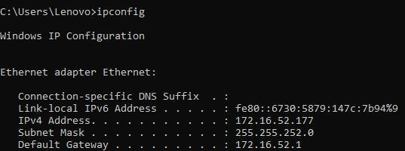

2.NSLOOKUP

The NSLOOKUP command is used to troubleshoot network connectivity issues in the system. Using the nslookup command, we can access the information related to our system’s DNS server, i.e., domain name and IP address. Command to enter in Prompt – nslookup

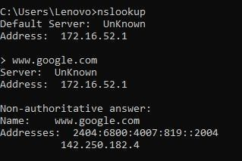

# HOSTNAME

The HOSTNAME command displays the hostname of the system. The hostname command is much easier to use than going into the system settings to search for it. Command to enter in Prompt - hostname

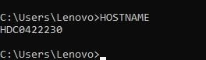

# PING

The Ping command is one of the most widely used commands in the prompt tool, as it allows the user to check the connectivity of our system to another host.

Command to enter in Prompt - ping www.destination_host_name.com

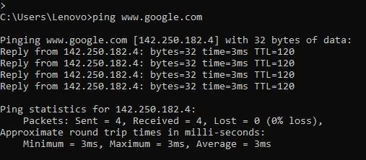

# TRACERT

The TRACERT command is used to trace the route during the transmission of the data packet over to the destination host and also provides us with the “hop” count during transmission.

Using the number of hops and the hop IP address, we can troubleshoot network issues and identify the point of the problem during the transmission of the data packet.

Command to enter in Prompt- tracert IP-address OR tracert www.destination_host_name.com

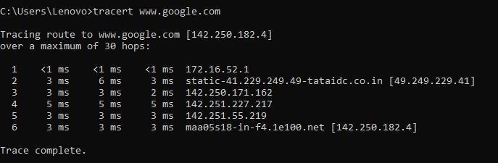

# NETSTAT

The Netstat command as the name suggests displays an overview of all the network connections in the device. The table shows detail about the connection protocol, address, and the current state of the network.

Command to enter in Prompt - netstat

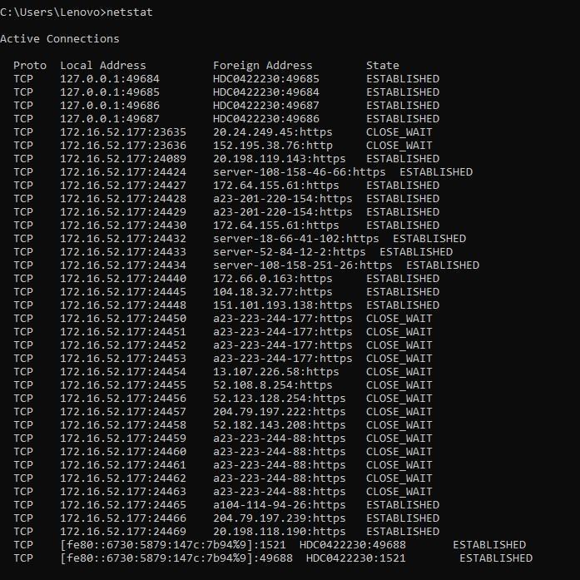

# ARP(Address Resolution Protocol)

The ARP command is used to access the mapping structure of IP addresses to the MAC address. This provides us with a better understanding of the transmission of packets in the network channel.

Command to enter in Prompt – arp

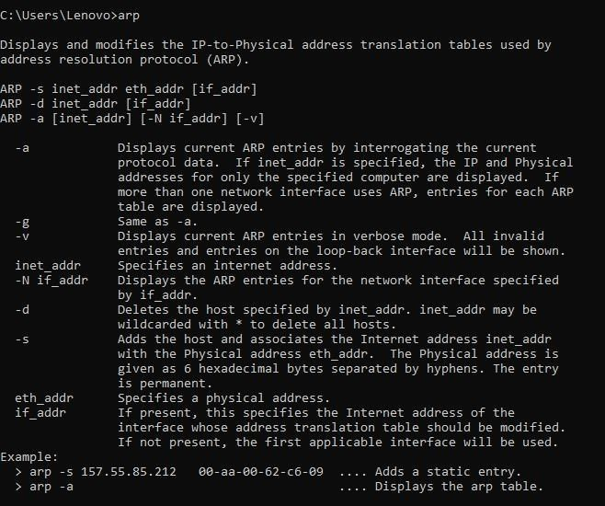

# SYSTEMINFO

Using the SYSTEMINFO command, we can access the system’s hardware and software details, such as processor data, booting data, Windows version, etc. Command to enter in Prompt – systeminfo

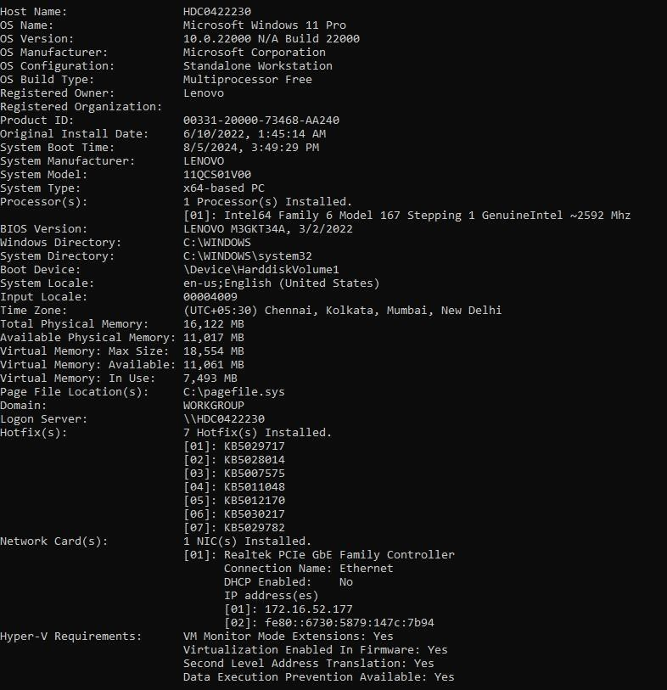

# ROUTE

Provides the data of routing data packets in the system over the communication channel.

Command to enter in Prompt – route print

